**Training and Attestation**

**Purpose**

The purpose of this document is to identify the training objectives completed, specific tasks completed, and attest that I completed the exercises utilizing my own understanding of the material.

**Exercise 2.9.2**

**Core**

1. Build and Configure the Network.
   1. Setup 2 Switches (2960) with 2 PCs.
   2. Setup console access.
   3. Setup ethernet cables.
   4. Configure PC hosts.
   5. Configure switches.
      1. Setup console and vty passwords.
      2. Setup privileged exec mode password.
2. Examine and understand the Switch MAC address table.

**Screenshots of Completion**

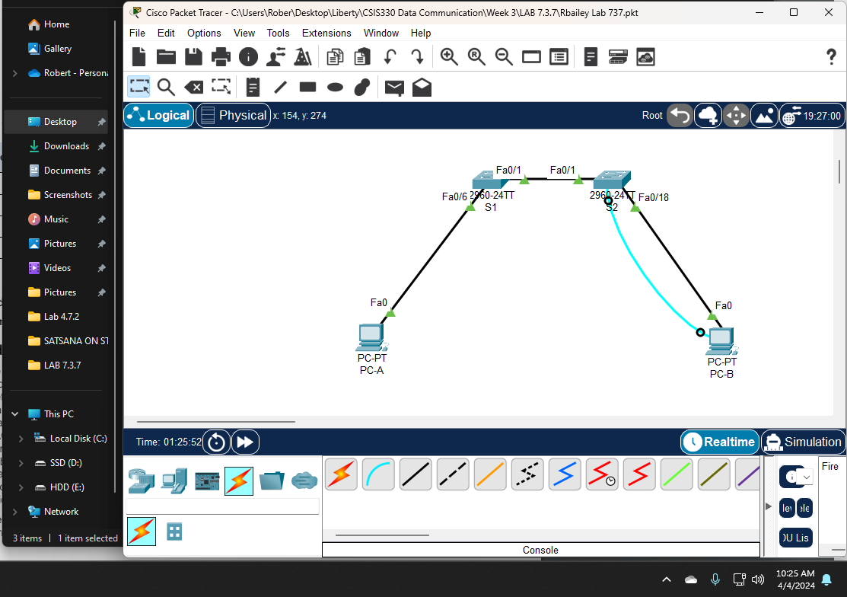

Note: Network was built from scratch. The packet tracer file is included.

**Attestation**

I certify that I completed all the work required for this lab using the skills and knowledge gained from completing the Liberty University course work and Official Cisco CCNA training material. The answers were my own and I did not plagiarize anyone else’s work.

